**PIZZA SALES SQL QUERIES**

1. KPI’s
2. Total Revenue:

select round(sum(total_price),2)as total_revenue from pizza_sales;

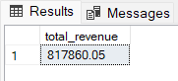

1. Average Order Value:

select sum(total_price) / count (distinct order_id) as Avg_order_value from pizza_sales;

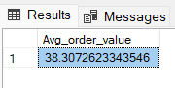

1. Total pizza sold:

select sum(quantity)as Total_pizza_sold from pizza_sales;

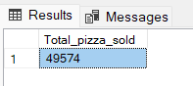

1. Total orders:

select count(distinct order_id)as Total_orders from pizza_sales;

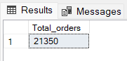

1. Average pizzas per order:

select cast(cast(sum(quantity) as decimal (10,2)) / cast(count(distinct order_id) as decimal (10,2)) as decimal (10,2)) as Avg_pizzas_per_order from pizza_sales;

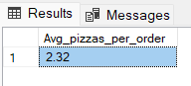

**PROBLEM STATEMENT**

1. Daily Trends for Total orders:



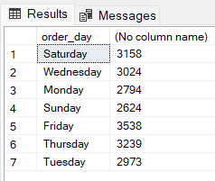

1. 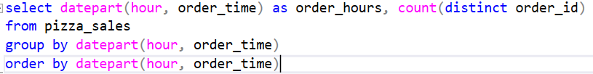Hourly Trends for Total orders:

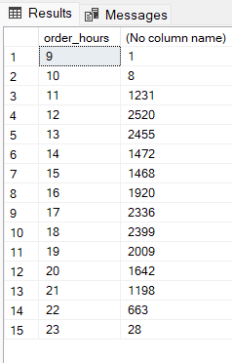

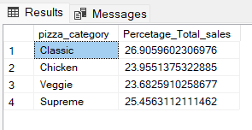

1. Percentage of sales by pizza category:

select pizza_category, sum(total_price) * 100 /

(select sum(total_price) from pizza_sales)

as Percetage_Total_sales from pizza_sales

group by pizza_category

1. Percentage of sales by pizza size:

select pizza_size, sum(total_price) * 100 / (select sum(total_price) from pizza_sales)

as Percetage_Total_sales_bysize from pizza_sales

group by pizza_size

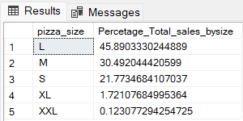

1. Total pizza sold by pizza category:

select pizza_category, sum(quantity) as total_pizza_sold

from pizza_sales

group by pizza_category

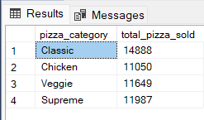

1. Top 5 best sellers by total pizza sold:

select top 5 pizza_name, sum(quantity) as total_pizza_sold from pizza_sales

group by pizza_name

order by sum(quantity) desc

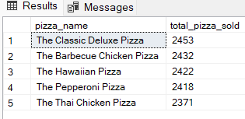

1. 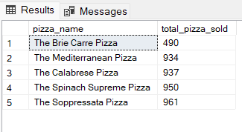Bottom 5 worst sellers by total pizza sold:

select top 5 pizza_name, sum(quantity) as total_pizza_sold

from pizza_sales

group by pizza_name

order by sum(quantity) asc